Experiment 8: Practice queries using Aggregate functions, Group by, Having clause and Order by clause

DEMO DATABASE:

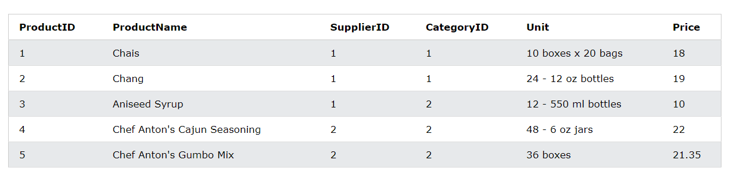

Command: count()

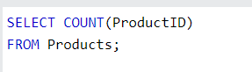

Output:

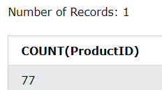

Command: avg()

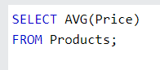

Output:

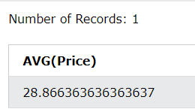

Command: sum()

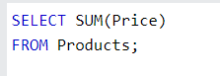

Output:

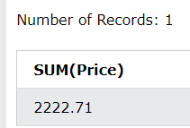

DEMO DATABASE:

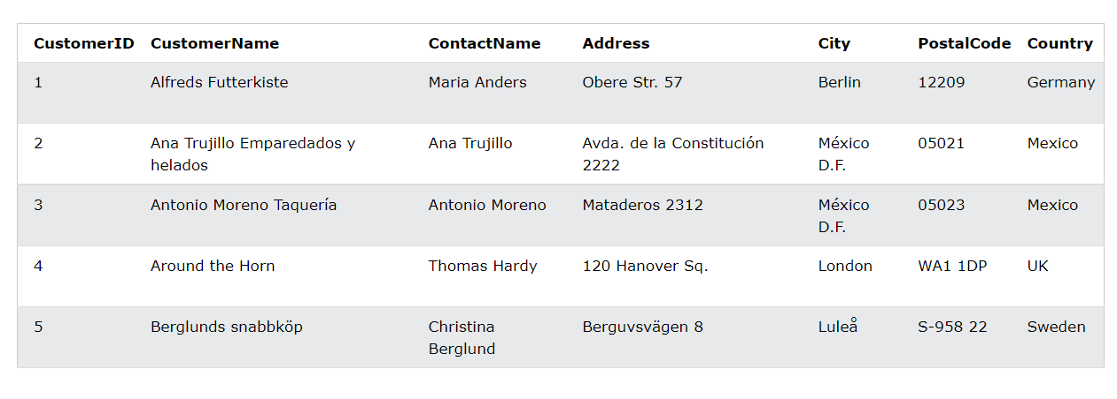

Command: GROUP BY

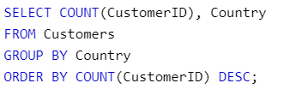

Output:

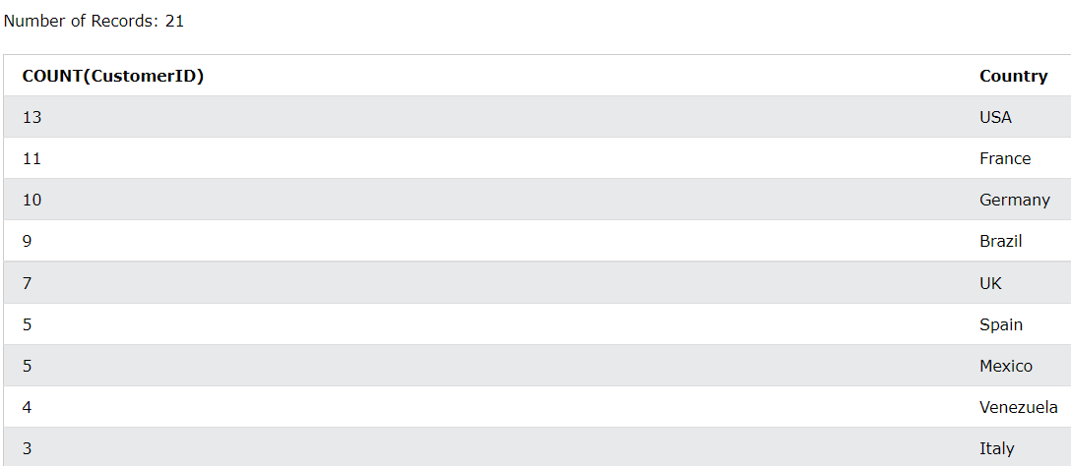

Command: HAVING

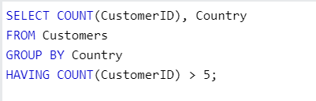

Output:

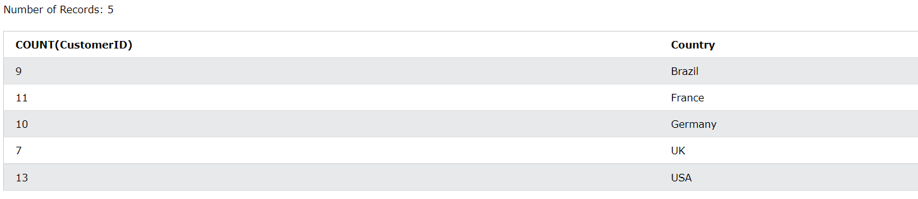

Command: ORDER BY

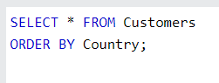

Output:

